FIT3138 Assignment 1 Part 2

Production Planning and Supply Chain Management

Data Sheet

Name : Jason Ching Yuen, Siu

Student Id : 31084222

Tutorial No : ………………

SAP Id (LEARN-###) LEARN-020

Instructions :

1. Complete your details above.
2. Copy and paste the five screenshots where indicated. Screenshots must be clear and easily readable.
3. Write you reflective essay on the last page (approx. 300 words)
4. Save the document as AAAA-9999999 Part 1.docx (or .pdf) where AAAA is your last name and 9999999 is your Student ID e.g. Smith-3678999 Part 1.docx
5. Upload the document to the submission link in Moodle.

Step A: Material Component Overview

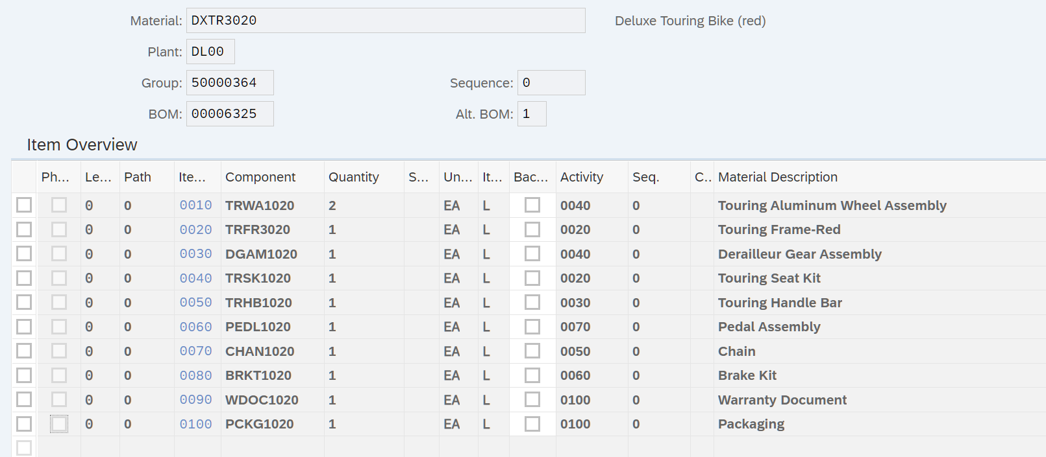

Step B: Change Rough-Cut Plan

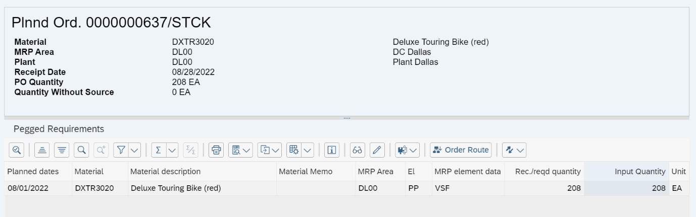

Step C: Pegged Requirements



Step D: Target/Actual Comparison

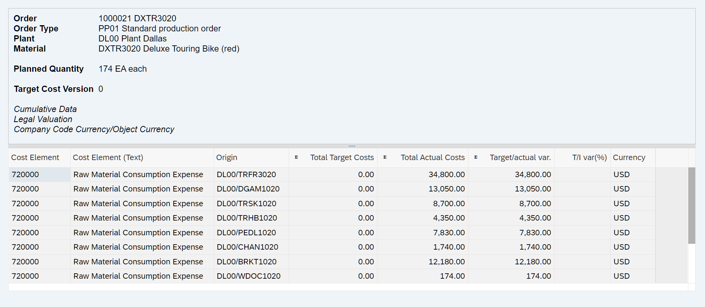

Step E: Orders: Actual/Plan/Variance

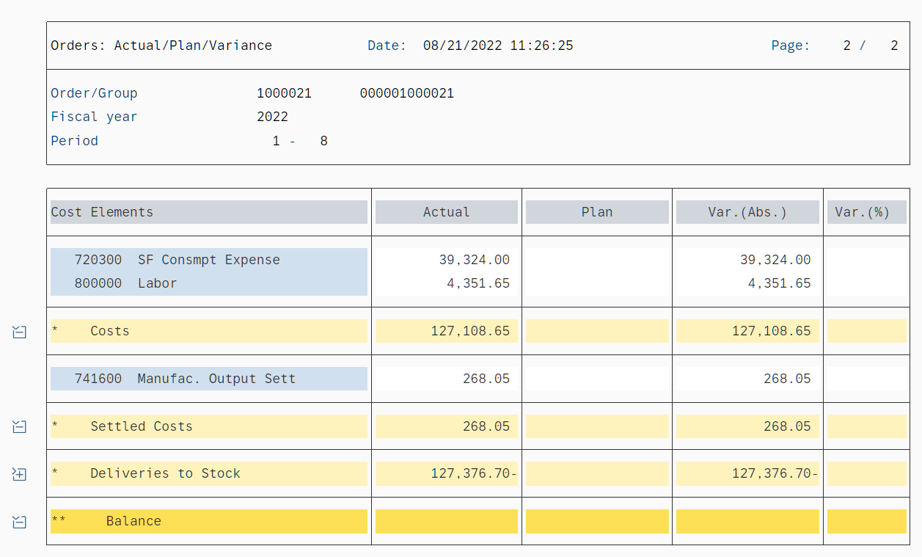

Reflective Essay